Projects Undertaken with its Industrial Application
Project 1: College Campus Network
A comprehensive enterprise network simulation project was developed to integrate all concepts learned during the training. The primary engineering initiative completed during the four-month tenure at GN Infotech involves the design, simulation, and logical architecture of a comprehensive Multi-Departmental College Campus Network Infrastructure. Engineered within the Cisco Packet Tracer platform, this enterprise simulation models a high-availability network backbone connecting six core institutional divisions: Faculty Offices, Computer Laboratories, the Library, the IT Department, Central Administration, and Student Hostels. The physical and logical layout of this architecture departs from a simple single-homed model, instead utilizing an advanced Four-Node Multi-Router Ring Topology. Four interconnected Cisco 2811 Integrated Services Routers (ISRs) designated as R0, R1, R2, and R3 form a redundant infrastructure loop. This ring structure provides path redundancy; if an active WAN link between any two routing nodes experiences a physical layer failure, traffic can be redirected along the alternative path of the ring, ensuring continuous uptime.

Project Overview and Multi-Router Ring Topology Design
This project focused on the design and implementation of a scalable and secure campus network for multiple departments. The network incorporates key networking concepts such as VLAN segmentation, VLSM-based IP addressing, static routing, and access control mechanisms to ensure efficient communication and security.
The design supports multiple departments including Faculty, Computer Labs, Library, IT, Administration, and Hostels, each logically segmented to reduce broadcast traffic and improve performance. Efficient IP address allocation is achieved using VLSM, while inter-network communication is enabled through static routing. Security is enhanced through the implementation of Access Control Lists (ACLs), restricting unauthorized access between departments.
The proposed network provides a reliable and scalable solution that can be extended in the future with advanced technologies such as dynamic routing protocols and Layer 3 switching, making it suitable for real-world campus environments.

Problem statement
Many institutions face challenges in managing network traffic, securing sensitive data and ensuring efficient communication between departments. Without proper network segmentation and security mechanisms, networks may experience congestion, unauthorized access and poor performance.The problem addressed in this project is the need to design a secure and efficient campus network that supports communication between departments while protecting critical systems and resources from unauthorized access.
The objectives of this project were:
- To design a structured campus network connecting multiple departments
- To implement VLANs to logically separate departmental networks
- To configure static routing between routers for inter-network communication
- To implement Router-on-a-Stick configuration for inter-VLAN communication
- To implement port security on switches to prevent unauthorized access
- To configure Access Control Lists (ACLs) to restrict access to sensitive networks
- To integrate wireless access points to support mobile devices within the campus
- To implement server infrastructure including web, DNS, and file servers

Scope of the Project
This project focuses on the design and simulation of a campus network using Cisco Packet Tracer. The network includes multiple routers, switches, wireless access points and servers that simulate the infrastructure of a real educational institution.
The scope of the project includes network design, VLAN configuration, routing implementation, server integration, and network security policies. The project does not involve physical hardware deployment but provides a realistic simulation of how such a network would operate in a real-world environment.

Network Topology
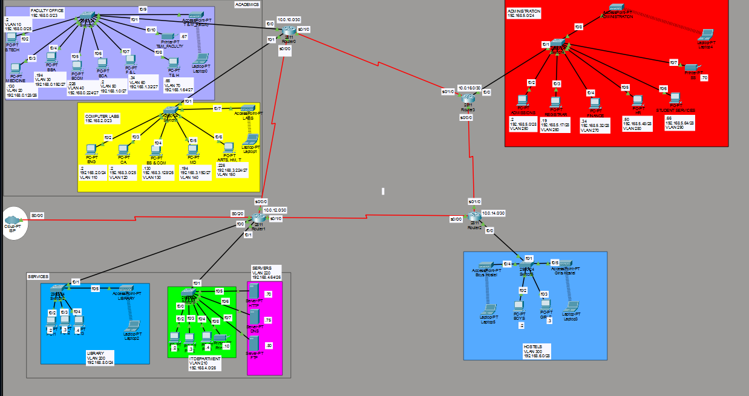
Figure 3.1 College Campus Network Topology
The network is designed using a campus architecture consisting of four interconnected routers forming a ring topology. Each router connects to one or more access switches that provide connectivity to departmental devices. Each department operates within its own subnet and VLAN to improve network organization and reduce broadcast traffic. The routers exchange traffic using static routing to allow communication between different departmental networks.

The network is designed using a structured approach that includes planning, configuration, and testing stages. First, the network topology is designed to connect all departments using routers and switches. VLANs are configured on switches to separate departmental traffic. Routers are configured with static routing and router-on-a-stick techniques to enable communication between VLANs. Security features such as port security and access control lists are implemented to restrict unauthorized access to sensitive networks.
Finally, server infrastructure is integrated into the network to provide services such as web hosting, DNS resolution, and file sharing. Connectivity and security policies are verified through network testing procedures.
System flow
When a device within the campus network sends data to another department, the packet is first forwarded to its default gateway configured on the router interface. The router examines the destination IP address and determines the appropriate route using its routing table.
If the destination is located in another VLAN or network, the router forwards the packet through the appropriate interface or subinterface using router-on-a-stick configuration. Before forwarding the packet, the router checks any configured Access Control Lists to determine whether the communication is permitted.
If the traffic meets the security policies, the packet is delivered to the destination device. If it violates the security rules, the packet is dropped to protect the network.

The figure below illustrates the system flow of the college campus network plan

(Users)Faculty PCs Lab PCs Library PCs
\ | /
\ | /
(Network system) Switches - VLANs
↓
Router
Inter-VLAN Routing
↓
Server VLAN
┌─────────┬─────────┬─────────┐
│ Web │ DNS │ FTP │
│ Server │ Server │ Server │
└─────────┴─────────┴─────────┘
Figure 3.2

Network Devices

Device | Quantity | Purpose
Routers | 4 | Route traffic between departmental networks
Switches | Multiple | Connect end devices within departments
Wireless Access Points | Several | Provide wireless connectivity
PCs | Multiple | Represent users in different departments(students, staff)
Laptops | Few | Wireless network clients
Servers | 3 | Website hosting,domain name resolution, file sharing
Printers | Multiple | Department printing

The network is built using a combination of routers, switches, wireless access points, servers, and end devices to ensure efficient connectivity and service delivery. Routers are used to interconnect different network segments and enable communication through static routing, while switches provide local connectivity within each department and support VLAN-based segmentation for improved performance and security. Wireless access points extend network access to mobile users in key areas such as labs, library, administration, and hostels. Servers are deployed to deliver essential services including web hosting, domain name resolution, and file transfer. End devices such as PCs, laptops, and printers allow
users to access network resources, while appropriate cabling ensures reliable communication between all components.

IP ADDRESSING PLAN
Department | VLAN | Network Address | Default Gateway
Faculty | VLAN 10  VLAN 20  VLAN 30  VLAN 40  VLAN 50  VLAN 60  VLAN 70 | 192.168.0.0/23  192.168.0.0/25  192.168.0.128/26  192.168.0192/27  192.168.0.224/27  192.168.1.0/27  192.168.1.32/27  192.168.1.64/27 | 192.168.0.1  192.168.0.129  192.168.0.193  192.168.0.225  192.168.1.1  192.168.1.33  192.168.1.65
Computer Labs | VLAN 110  VLAN 120  VLAN 130  VLAN 140  VLAN 150 | 192.168.2.0/23  192.168.2.0/24  192.168.3.0/25  192.168.3.128/26  192.168.3.192/27  192.168.3.224/27 | 192.168.2.1  192.168.3.1  192.168.3.129  192.168.3.193  192.168.3.225
Library | VLAN 200 | 192.168.8.0/24 | 192.168.8.1
IT Department | VLAN 210  VLAN 220 | 192.168.4.0/26  192.168.4.0/26  192.168.4.64/26 | 192.168.4.1  192.168.4.65
Administration | VLAN 250  VLAN 260  VLAN 270  VLAN 280  VLAN 290 | 192.168.5.0/24  192.168.5.0/28  192.168.5.17/28  192.168.5.32/28  192.168.5.48/28  192.168.5.64/28 | 192.168.5.1  192.168.5.18  192.168.5.33  192.168.5.49  192.168.5.65
Hostels | VLAN 60 | 192.168.6.0/25 | 192.168.6.1
Servers | VLAN 70 | 192.168.7.0/25 | 192.168.7.1

Each subnet represents a different department within the institution. Instead of using a default subnet mask of /24 everywhere which is wasteful, I used variable length subnet masking (VSLM) based on department size.
/23 (255.255.254.0)
Used for Faculty Offices and Computer Labs
Supports 510 hosts, larger number of pcs
Splitts labs into multiple networks according to departments
/24 (255.255.255.0)
Used for admin and library
Balanced choice
Easy to manage
Allows future expansion, medium growth expected,office scaling
/26 (255.255.255.128)
Used for smaller department IT
Saves IP space
Still supports 126 hosts
/28(255.255.255.128)
Used for the smallest department Hostel
Saves ip space - supports 14 hosts
WAN Links
Link | Subnet
R0 - R1 | 10.0.10.0/30
R1 - R2 | 10.0.12.0/30
R2 -R3 | 10.0.14.0/30
R0 -R3 | 10.0.16.0/30

Each WAN link uses /30 (255.255.255.252) to conserve space and follow point to point design best practices. Only 2 usable IPs.

3.2.2.1 Static IP Addressing Configuration:
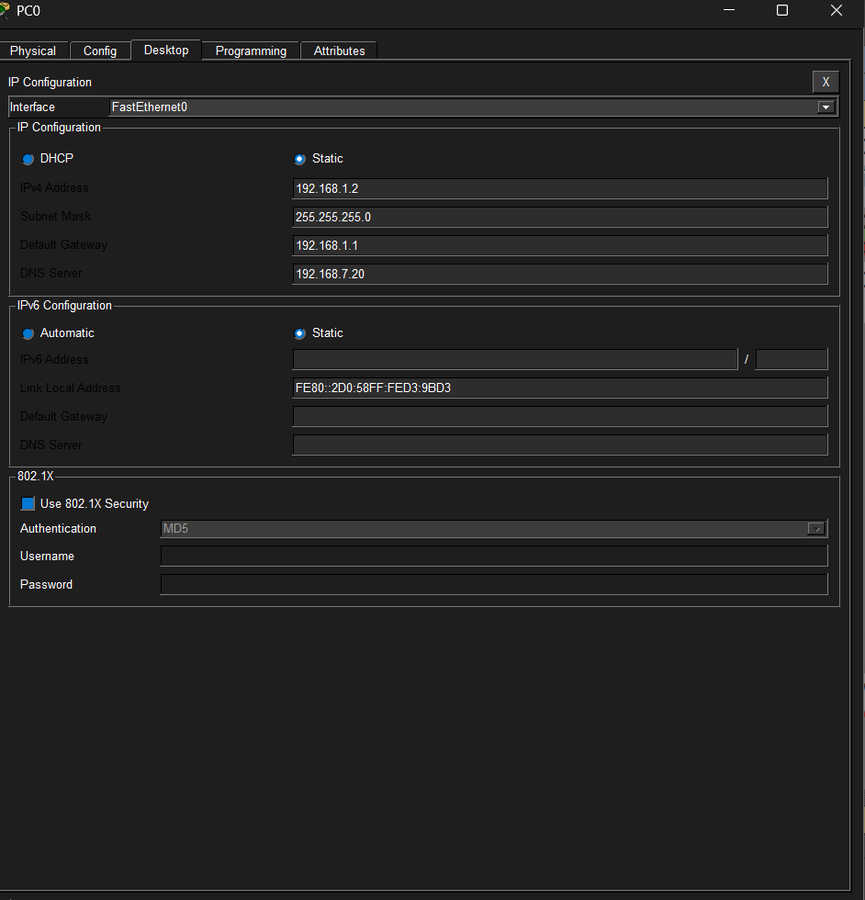
Figure 3.3 Static ip addressing on a pc

STATIC ROUTING CONFIGURATION
Static routing was configured on the routers to enable communication between the different departmental networks. Each router contains routes pointing to the next-hop router for networks that are not directly connected.
Static routing was chosen because it is simple to configure and suitable for small to medium sized networks where routes do not change frequently.

Academics(Router 0) Static routing configuration:
Router>enable
Router#configure terminal
Router(config)#hostname Academics
Academics(config)#enable secret AJCM_Academics
Academics(config)#service password encryption
Academics(config)#interface Serial0/0/0
Academics(config-if)#ip address 10.0.10.1 255.255.255.252
Academics(config-if)#clockrate 64000
Academics(config-if)#no shutdown
Academics(config-if)#exit

Academics(config)#interface Serial0/1/0
Academics(config-if)#ip address 10.0.16.2 255.255.255.252
Academics(config-if)#no shutdown
Academics(config-if)#exit

Academics(config)#interface FastEthernet0/0
Academics(config-if)#no shutdown
Academics(config-if)#exit

Academics(config)#ip route 192.168.8.0 255.255.255.0 10.0.10.2
Academics(config)#ip route 192.168.4.0 255.255.255.128 10.0.10.2
Academics(config)#ip route 192.168.6.0 255.255.255.240 10.0.10.2
Academics(config)#ip route 192.168.5.0 255.255.255.0 10.0.16.1

Verifying configuration:

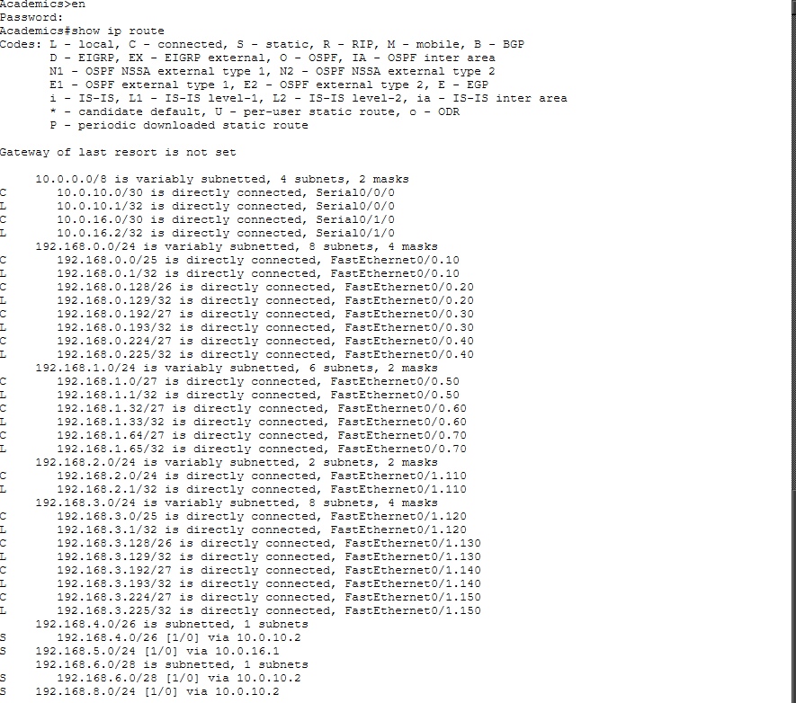
Figure 3.4 Static routing of routers

SWITCHING DESIGN
Layer 2 switches provide connectivity within each department. Each department is assigned a dedicated switch to ensure better performance, fault isolation and simplified management.
Switch ports connected to end devices are configured as access ports, each assigned to a specific VLAN. Links between switches and routers are configured as trunk ports using 802.1Q encapsulation, allowing multiple VLANs to pass through a single link.

Verifying configuration:
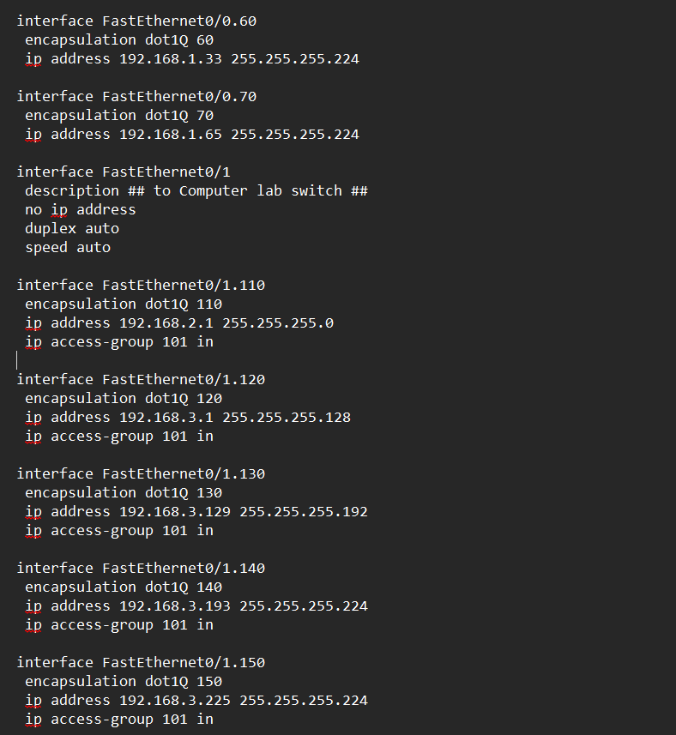
Figure 3.5 Switching Interfaces

VLAN IMPLEMENTATION
Virtual Local Area Networks (VLANs) were implemented on switches to logically segment the network. Each department was assigned a unique VLAN ID to isolate traffic between departments and reduce broadcast domains. This segmentation improves network performance and security by ensuring that traffic from one
department does not unnecessarily affect other departments. VLANs also increase security.
VLAN creation and naming:
Switch>enable
Switch#configure terminal
Switch(config)#hostname Adim_Sw
Admin_Sw(config)#enable password AJCM_Admin
Admin_Sw(config)# vlan 250
Admin_Sw(config-vlan)# name ADMISSIONS
Admin_Sw(config-vlan)# vlan 260
Adim_Sw(config-vlan)# name REGISTRAR
Admin_Sw(config-vlan)# vlan 270
Admin_Sw (config-vlan)# name FINANCE
Admin_Sw (config-vlan)# vlan 280
Admin_Sw (config-vlan)# name HR
Admin_Sw (config-vlan)# vlan 290
Admin_Sw (config-vlan)# name STUDENTS_SERVICES
Admin_Sw (config-vlan)#exit

VLAN Port assignment
Admin_Sw (config)#interface FastEthernet 0/2
Admin_Sw (config-if)# switchport access vlan 250
Admin_Sw (config-if)#switchport mode access

Admin_Sw (config-if)#interface FastEthernet 0/3
Admin_Sw (config-if)# switchport access vlan 260
Admin_Sw (config-if)#switchport mode access

Admin_Sw (config-if)#interface FastEthernet0/4
Admin_Sw (config-if)# switchport access vlan 270
Admin_Sw (config-if)#switchport mode access

Admin_Sw (config-if)#interface FastEthernet 0/5
Admin_Sw (config-if)# switchport access vlan 280
Admin_Sw (config-if)#switchport mode access

Admin_Sw (config-if)#interface range FastEthernet 0/6 - 8
Admin_Sw (config-if)# switchport access vlan 290
Admin_Sw (config-if)#switchport mode access
Admin_Sw(config-if)#exit

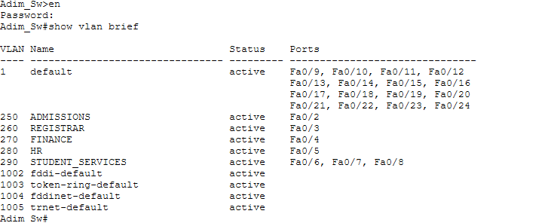
Figure 3.6 Verification of VLAN configured

ROUTER-ON-A-STICK CONFIGURATION
Router-on-a-Stick configuration was implemented to enable inter-VLAN communication between the IT department and the server network using a single
router interface. The router interface connected to the switch was configured as a trunk port, while multiple router subinterfaces were created to handle traffic from different VLANs.
Admin_Sw>en
Password:
Admin_Sw#configure terminal
Admin_Sw(config)#interface FastEthernet 0/1
Admin_Sw (config-if)#switchport mode trunk
Admin_Sw (config-if)# switchport trunk allowed vlan all

Sub-interface creation on Administration Router:
Router>en
Router#configure terminal
Router(config)#hostname Admin
Admin(config)#enable password AJCM_Admin
Admin(config)#interface FastEthernet 0/0
Admin(config-if)#no ip address
Admin(config-if)#no shutdown

Configure VLAN 250 Subinterface
Admin(config-if)#interface FastEthernet 0/0.250
Admin(config-subif)#encapsulation dot1Q 250
Admin(config-subif)#ip address 192.168.5.1 255.255.255.240
Admin(config-subif)#exit

Configure VLAN 260 Subinterface
Admin(config)#interface FastEthernet 0/0.260
Admin(config-subif)#encapsulation dot1Q 260
Admin(config-subif)#ip address 192.168.5.18 255.255.255.240
Admin(config-subif)#exit

Configure VLAN 270 Subinterface
Admin(config)#interface FastEthernet 0/0.270
Admin(config-subif)#encapsulation dot1Q 270
Admin(config-subif)#ip address 192.168.5.33 255.255.255.240
Admin(config-subif)#exit

Configure VLAN 280 Subinterface
Admin(config)#interface FastEthernet 0/0.280
Admin(config-subif)#encapsulation dot1Q 280
Admin(config-subif)#ip address 192.168.5.49 255.255.255.240
Admin(config-subif)#exit

Configure VLAN 290 Subinterface
Admin(config)#interface FastEthernet 0/0.290
Admin(config-subif)#encapsulation dot1Q 290
Admin(config-subif)#ip address 192.168.5.65 255.255.255.240
Admin(config-subif)#exit

Verifying configuration:
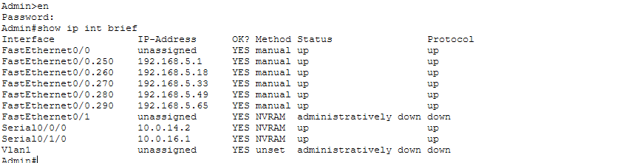

Figure 3.7 verification of ip interfaces configured

Verifying router-on-a-stick configuration:
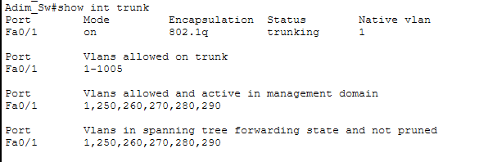
Figure 3.8 Verification of Switch Trunk Configuration
PORT-SECURITY IMPLEMENTATION
Port security was configured on switch access ports to prevent unauthorized devices from connecting to the network. Each switch port allows only a limited number of MAC addresses. If an unknown device attempts to connect, the port automatically shuts down.
This feature helps protect the network from unauthorized access and potential security threats.
Port- Security on computer labs:
Switch>en
Switch#configure terminal
Switch(config)#hostname CompLab
CompLab(config)#enable password AJCM_CompLab
CompLab(config)# interface range FastEthernet 0/1 - 24
CompLab(config-if)#switchport port-security
CompLab(config-if)#switchport port-security maximum 1
CompLab(config-if)#switchport port-security mac-address sticky
CompLab(config-if)#switchport port-security violation shutdown
CompLab(config-if)#exit

Verifying configuration:
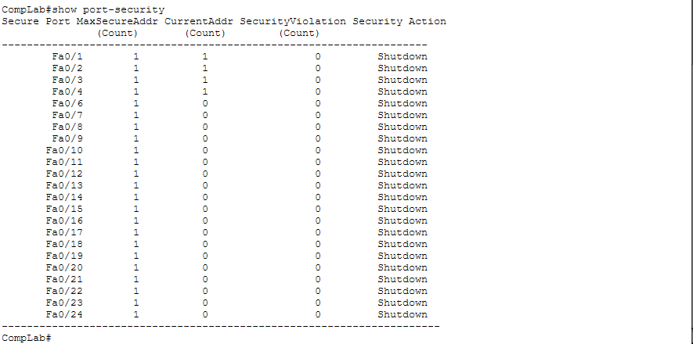
Figure 3.9 Verification of port-security violations
ACESS CONTROL LISTS (ACLs)
Extended Access Control Lists were implemented to control communication between departments. Certain departments such as the student laboratories and hostels are restricted from accessing sensitive networks such as the IT department and administration network. Student networks such as the computer laboratories and hostels are restricted from accessing the server VLAN to prevent misuse of critical resources. Only authorized departments such as Faculty, IT, and Administration are permitted to access the server infrastructure.
These restrictions ensure that sensitive systems and administrative resources remain protected from unauthorized access. Extended ACLs are placed close to source and help in reducing unnecessary traffic across network.
Security policy implemented:
Source Network | Destination Network | Action
Labs | IT, Admin, Faculty, Servers | Deny
Library | Admin, IT, Faculty, Servers | Deny
Hostels | Admin, IT, Faculty, Servers | Deny
Faculty | All networks | Allow
IT | All networks | Allow
Admin | All networks | Allow

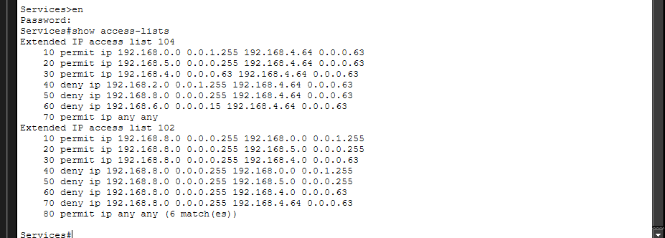
Figure 3.10 Implemented Access Control Lists on Services Router
Protecting intellectual property, student records, and operational databases requires strict perimeter security enforcement. In this design, security is established through a combination of Layer-2 Port Security on access switches and Extended Access Control Lists (ACLs) bound to the routing interfaces.
At the access layer, Layer-2 Port Security safeguards edge hardware ports against unauthorized physical intrusions. Each switch interface is limited to a maximum count of one authorized MAC address. If an unknown or rogue host is connected to an active wall drop, the switch automatically triggers a Shutdown state on that interface, isolating the port and generating an alert to prevent unauthorized network access.
At the network layer, Extended ACLs enforce a strict "least privilege" security architecture across the campus infrastructure. To minimize resource load on the multi-router backbone, these extended filters are applied close to the traffic source. The implemented security matrix blocks untrusted user spaces from accessing sensitive networks:
Student Network Restrictions: Devices located in the Computer Labs and Hostels are blocked from establishing network connections with the Central Administration, IT Management, and Faculty subnets.
Server Infrastructure Defense: A dedicated server zone (hosting the campus Web portal, DNS lookup resolution, and FTP shared file storage) is isolated within its own server network. The ACL rules block direct access from student environments to prevent resource abuse, while allowing authorized segments (Faculty, IT, and Administration) to access these core servers securely.
Any traffic packet that breaks these rules is dropped at the incoming router interface, protecting administrative assets from internal network threats. This multi-layered approach balances open access for students with reliable data protection for core business systems.
Verifying reachability via ping:
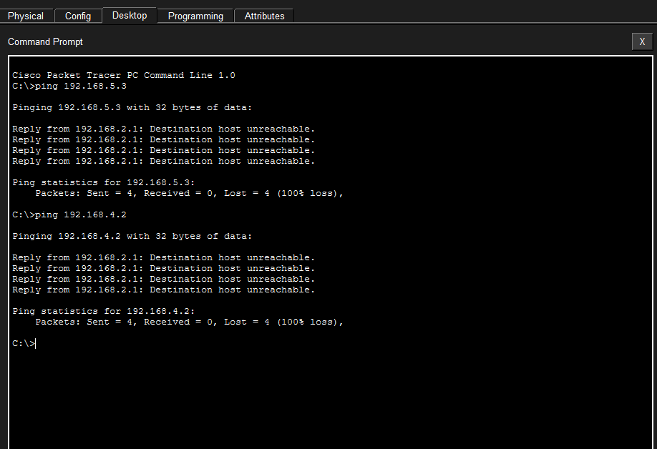
Figure 3.11 Verification of Reachability of Computer Labs to Admin and IT Network
Device Security
Basic device security was implemented across all routers and switches by configuring privileged EXEC mode passwords using the "enable password" command. This ensures that only authorized personnel can access and modify device configurations, thereby protecting the network from unauthorized changes. Password encryption was also enabled to prevent plain-text exposure of credentials in configuration files. This measure adds a foundational layer of security to the network infrastructure by restricting administrative access and safeguarding critical network operations.
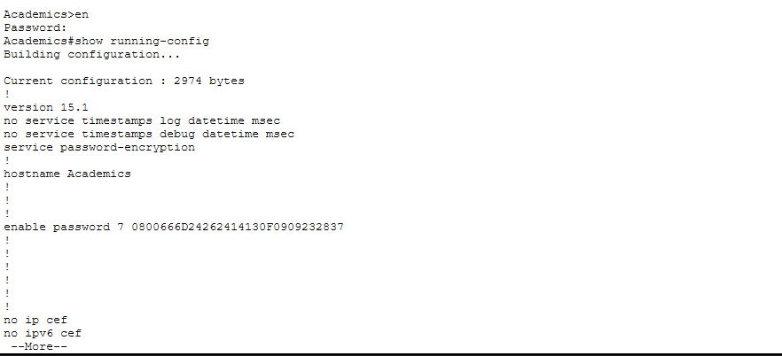
Figure 3.12 Verification of Device Security Using Password Encryption

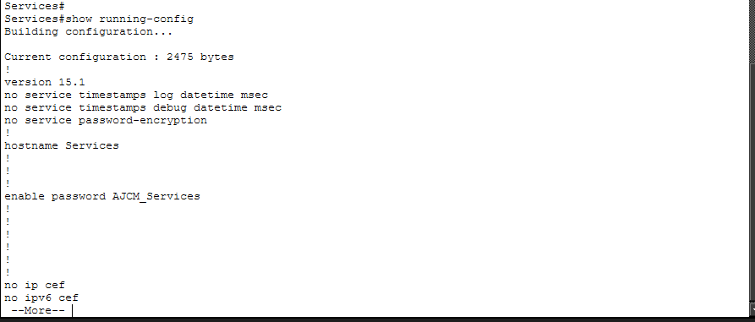
Figure 3.13 Verification of Device Security Using Enable Password Without Encryption
WIRELESS NETWORK INTEGRATION
Wireless access points were added to the network to provide wireless connectivity for laptops and mobile devices. These access points are connected to the access switches and operate within the same VLAN as the wired devices of each department. Wireless security was configured using WPA2 authentication to ensure that only authorized users can access the wireless network.

Example wireless configuration:
Parameter | Configuration
SSID | Library
Security | WPA2
Authentication | Pre-shared key

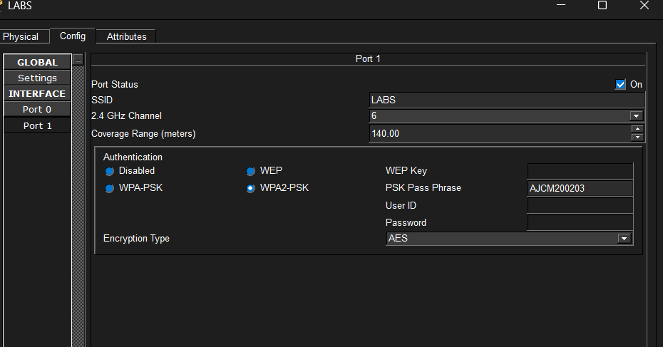
Figure 3.14 Configuration of WiFi Network for Wireless Devices
Dynamic IP Address Allocation for Wireless Users
To simplify network administration and improve scalability, all wireless users within the campus network are configured to obtain IP addresses automatically through the Dynamic Host Configuration Protocol (DHCP). A centralized DHCP server maintains a pool of available IP addresses and assigns them dynamically whenever a wireless device connects to the network. This approach eliminates the need for manual IP configuration, reduces addressing errors, and ensures efficient utilization of network resources. Additionally, DHCP automatically provides other network parameters such as the default gateway, subnet mask, and DNS server information, enabling seamless connectivity for wireless users.

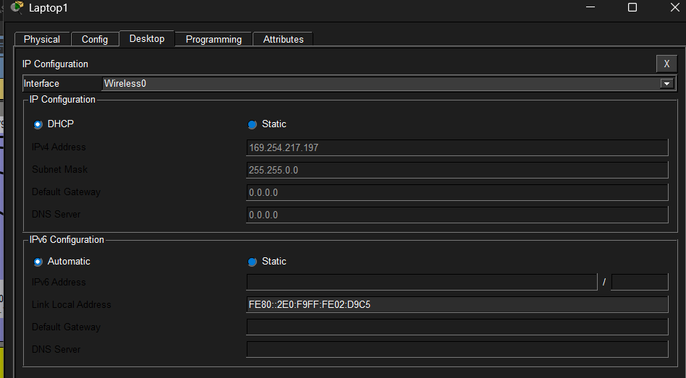
Figure 3.15 Dynamic IP Addressing of Wireless Devices
SERVER INFRASTRUCTURE
A dedicated server network was created using VLAN 220 to host the campus servers. This server network is connected to the IT department switch and routed through the main router using Router on a Stick configuration. The server VLAN isolates critical services from regular user networks while still allowing controlled access from authorized departments.
Server Types Implemented:
The network includes several servers providing key services.
Server | IP Address | Function
Web Server | 192.168.4.70 | Hosts campus website
DNS Server | 192.168.4.75 | Resolves domain names
File Server | 192.168.4.80 | Shared storage for faculty

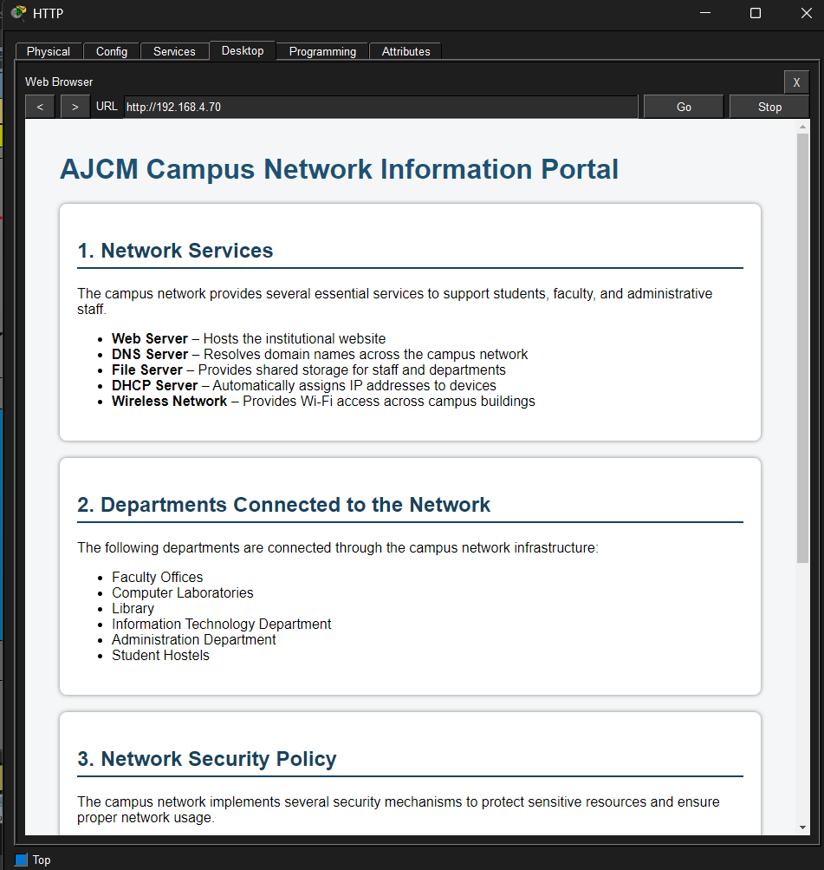
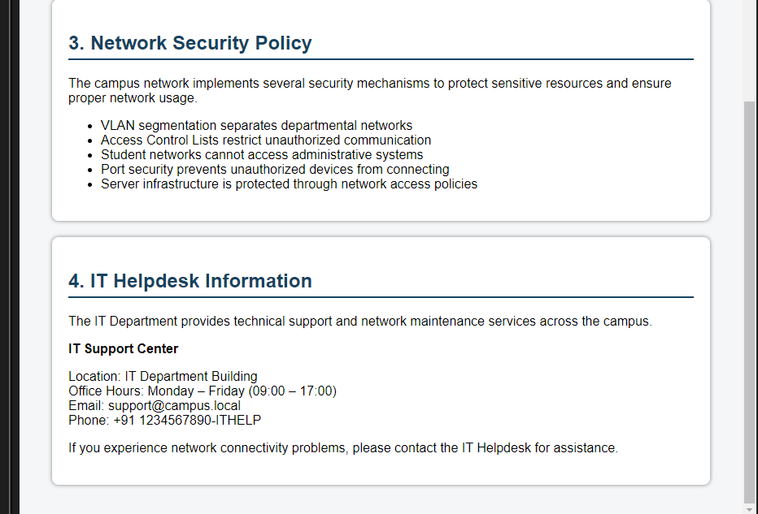
Figure 3.16 Verification of Campus Website
NETWORK TESTING AND VERIFICATION
To ensure the correct operation of the network, several verification and testing procedures were performed after configuration. These tests were aimed at validating connectivity, routing, VLAN segmentation, and security policies. Basic connectivity between devices and across different departments was verified using the ping command. Routing paths between networks were analyzed using tracert (or traceroute), confirming that packets follow the intended routes through the configured routers.
Key configuration aspects were validated using standard show commands such as show ip route to confirm routing tables, show vlan brief to verify VLAN assignments, and show interfaces trunk to ensure proper trunk link operation. Additionally, show running-config was used to review active configurations on network devices.
Access Control Lists (ACLs) were tested by attempting communication between restricted and permitted networks, ensuring that defined security policies were correctly enforced.
Overall, these verification steps confirmed that the network operates as intended, with proper connectivity, segmentation, and security across all departments.
CHALLENGES AND SOLUTIONS
During the design and implementation of the network, several challenges were encountered. Appropriate solutions were applied to ensure optimal performance, security, and scalability.

Challenge | Solution implemented
Designing a network for departments with different sizes | Applied VLSM to allocate subnet sizes based on the number of required hosts, ensuring efficient IP utilization
Managing large number of devices in computer labs | Assigned a /23 subnet to accommodate a high number of hosts without fragmentation
Ensuring secure communication between departments | Configured Access Control Lists (ACLs) to restrict unauthorized access between networks
Reducing broadcast traffic across the network | Implemented VLAN segmentation to isolate broadcast domains
Enabling communication between VLANs | Used Router-on-a-Stick for inter-VLAN routing
Efficient use of WAN links between routers | Used /30 subnets to minimize IP address wastage
Preventing unnecessary traffic flow | Placed extended ACLs close to the source
Maintaining simplicity in routing configuration | Used static routing for predictable and controlled routing behavior
Network testing and validation | Performed verification using commands like ping, tracert, and show commands
Planning for future expansion | Designed scalable IP addressing and VLAN structure

These challenges and solutions demonstrate practical problem-solving skills and reflect real-world network design considerations.
SCALABILITY AND FUTURE IMPROVEMENTS
The network has been designed with scalability in mind to accommodate future growth in users, departments, and services. The use of VLSM allows flexible IP allocation, ensuring that additional devices can be integrated without major redesign.
The VLAN-based structure enables new departments or user groups to be added easily by assigning new VLAN IDs and subnets. Similarly, the modular use of routers and switches allows the network to expand across additional buildings or floors with minimal changes to the existing infrastructure.
In the future, the network can be enhanced by implementing dynamic routing protocols such as OSPF or EIGRP, which would improve scalability and reduce manual configuration. The introduction of Layer 3 switches can further optimize inter-VLAN routing by increasing speed and reducing dependency on routers.
Additional improvements may include:
- Implementation of DHCP for automatic IP address assignment
- Deployment of network monitoring tools for performance analysis
- Use of redundancy protocols such as STP enhancements and EtherChannel
- Integration of advanced security mechanisms like firewalls and intrusion detection systems
- Overall, the current design provides a strong foundation that can evolve into a more advanced and enterprise-level network.

Industrial Application and Corporate Business Case
In production enterprise networks, uncontrolled broadcast traffic and flat network layouts pose significant operational risks. The industrial application of this campus architecture centers on deploying Variable Length Subnet Masking (VLSM) and Virtual Local Area Network (VLAN) segmentation to align network resources with organizational scale.
Rather than deploying a wasteful, uniform /24 classful mask across all zones, a customized VLSM schema optimizes address allocation based on host density:
- High-Density Zones: The Faculty Offices and Computer Laboratories utilize an efficient /23 subnet mask, creating a larger host pool that supports up to 510 physical endpoints per sector without network fragmentation.
- Medium-Density Zones: Central Administration and the Library deployment areas are allocated standard /24 subnets to facilitate predictable office scaling and future expansion.
- Low-Density & Specialized Zones: Small infrastructure areas like the IT Department and the Server Network are optimized down to /26 subnets (supporting up to 126 endpoints). This approach prevents IP wasting and isolates critical assets from standard user domains
- Point-to-Point WAN Connectors: Every inter-router serial link within the ring topology uses a strict /30 mask (enforcing a 255.255.255.252 subnet footprint). This limits the link to exactly two usable IP endpoints, matching public telecom routing best practices and conserving valuable address space.
From a business standpoint, this segmentation ensures that high-volume broadcast traffic generated within student spaces (such as the Hostels or Computer Labs) remains logically contained within its own layer-2 broadcast domain. This separation keeps traffic from spilling into critical administrative segments, preserving bandwidth and protecting system performance.

Project 2
Design and Implementation of a Multi-Branch Enterprise Network Using VLANs, VLSM, OSPF, Wireless Access, and Access Control Lists
The second primary engineering initiative completed during the four-month tenure at GN Infotech implements a three-tier hierarchical architecture (Core, Distribution, Access) to connect a main Corporate Headquarters (HQ) with two Remote Branch Offices. The sites are linked across a wide area network using high-speed point-to-point serial lines. The internal LANs are segmented into isolated departmental VLANs, with all routing, switching, and edge transitions managed dynamically via OSPF.
Project 2 Overview
This project focuses on the design and implementation of a scalable enterprise network connecting a Headquarters (HQ) and two branch offices. The network provides secure communication between departments through VLAN segmentation, dynamic routing using OSPF, centralized services, wireless connectivity, and security enforcement through Access Control Lists (ACLs).
The objective is to simulate a real-world enterprise environment that supports multiple departments while maintaining security, scalability, and efficient resource utilization.
Project Objectives
- Design a hierarchical enterprise network topology.
- Implement VLAN segmentation for departmental separation.
- Apply VLSM for efficient IP address allocation.
- Configure Router-on-a-Stick for Inter-VLAN Routing.
- Implement OSPF Dynamic Routing between HQ and branch offices.
- Deploy centralized server services.
- Implement dedicated printer and wireless VLANs.
- Configure enterprise security using ACLs.
- Ensure end-to-end connectivity and scalability.

OSPF Network Topology

HQ (R0) AREA 0
/ \
/ \
/ \
AREA 1 AREA 2

Branch 1 Branch 2
(R1) (R2)

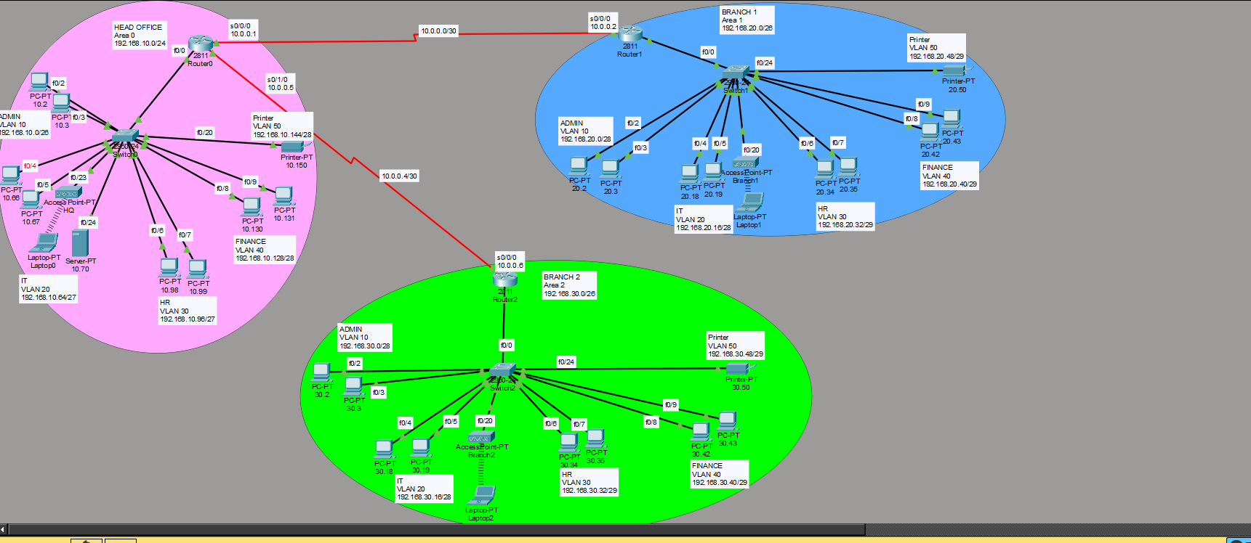
Figure 3.17 Multi-Branch Enterprise Network Topology
The enterprise network consists of a Headquarters (HQ) and two branch offices. The Headquarters includes Router R1, Switch SW1, a server, a printer, a wireless access point, and several departmental PCs. Branch Office 1 contains Router R2, Switch SW2, a printer, a wireless access point, and departmental PCs. Similarly, Branch Office 2 is equipped with Router R3, Switch SW3, a printer, a wireless access point, and departmental PCs. The network is interconnected through WAN connectivity, with the Headquarters directly connected to both Branch Office 1 and Branch Office 2. To enable efficient communication and automatic route sharing between all locations, the network uses the OSPF (Open Shortest Path First) routing protocol for dynamic route exchange.

IP Addressing Plan Using VLSM

Headquarters (192.168.10.0/24)
VLAN ID | DEPARTMENT | NETWORK ADDRESS | DEFAULT GATEWAY
10 | Administration | 192.168.10.0/26 | 192.168.10.1
20 | Information Technology (IT) | 192.168.10.64/27 | 192.168.10.65
30 | Human Resources (HR) | 192.168.10.96/27 | 192.168.10.97
40 | Finance | 192.168.10.128/28 | 192.168.10.129
50 | Printers | 192.168.10.144/28 | 192.168.10.145

Branch Office 1 (192.168.20.0/26)
VLAN ID | Department | Network Address | Default Gateway
10 | Administration | 192.168.20.0/28 | 192.168.20.1
20 | Information Technology (IT) | 192.168.20.16/28 | 192.168.20.17
30 | Human Resources (HR) | 192.168.20.32/29 | 192.168.20.33
40 | Finance | 192.168.20.40/29 | 192.168.20.41
50 | Printers | 192.168.20.48/29 | 192.168.20.49

Branch Office 2 (192.168.30.0/26)
VLAN ID | Department | Network Address | Default Gateway
10 | Administration | 192.168.30.0/28 | 192.168.30.1
20 | Information Technology (IT) | 192.168.30.16/28 | 192.168.30.17
30 | Human Resources (HR) | 192.168.30.32/29 | 192.168.30.33
40 | Finance | 192.168.30.40/29 | 192.168.30.41
50 | Printers | 192.168.30.48/29 | 192.168.30.49

WAN Addressing Scheme - Network Assignments
Connection | Network Address | Subnet Mask
HQ ↔ Branch 1 | 10.0.0.0/30 | 255.255.255.252
HQ ↔ Branch 2 | 10.0.0.4/30 | 255.255.255.252

Router Interface Addressing
Router | IP Address
HQ Router (R1) | 10.0.0.1
Branch Office 1 Router (R2) | 10.0.0.2
HQ Router (R1) | 10.0.0.5
Branch Office 2 Router (R3) | 10.0.0.6
Subnet Mask for WAN Links: 255.255.255.252 (/30)
CLI Command Script Execution
HQ Router
Router>enable
Router#config t
Router(config)#hostname RHQ
RHQ(config)# interface serial 0/0/0
RHQ(config-if)# ip address 10.0.0.1 255.255.255.252
RHQ(config-if)# clock rate 64000
RHQ(config-if)# no shutdown
RHQ(config-if)# exit

RHQ(config)# interface serial 0/1/0
RHQ(config-if)# ip address 10.0.0.5 255.255.255.252
RHQ(config-if)# clock rate 64000
RHQ(config-if)# no shutdown
RHQ(config-if)# exit

RHQ(config)# router ospf 1
RHQ(config-router)# router-id 1.1.1.1
RHQ(config-router)# network 10.0.0.0 0.0.0.3 area 0
RHQ(config-router)# network 10.0.0.4 0.0.0.3 area 0
RHQ(config-router)# network 192.168.10.0 0.0.0.255 area 0
RHQ(config-router)#end
RHQ#write memory

BRANCH 1 ROUTER
Router>enable
Router#config t
Router(config)#hostname BR1
BR1(config)# interface serial 0/0/0
BR1(config-if)# ip address 10.0.0.2 255.255.255.252
BR1(config-if)# no shutdown
BR1(config-if)# exit

BR1(config)# router ospf 1
BR1(config-router)# router-id 2.2.2.2
BR1(config-router)# network 10.0.0.0 0.0.0.3 area 0
BR1(config-router)# network 192.168.20.0 0.0.0.63 area 1
BR1(config-router)#end
BR1#write memory

BRANCH 2 ROUTER
Router>enable
Router#config t
Router(config)#hostname BR2
BR2(config)# interface serial 0/0/0
BR2(config-if)# ip address 10.0.0.6 255.255.255.252
BR2(config-if)# no shutdown
BR2(config-if)# exit

BR2(config)# router ospf 1
BR2(config-router)# router-id 3.3.3.3
BR2(config-router)# network 10.0.0.4 0.0.0.3 area 0
BR1(config-router)# network 192.168.30.0 0.0.0.63 area 2
BR2(config-router)#end
BR2#write memory

Verifying configuration between the two branches and the HQ using show ip ospf neighbor
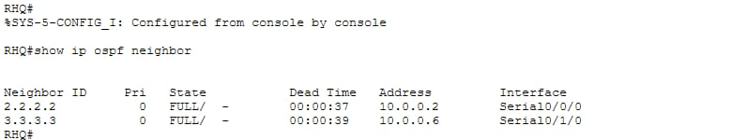
Verifying reachability from HQ router to the two branches using ping command
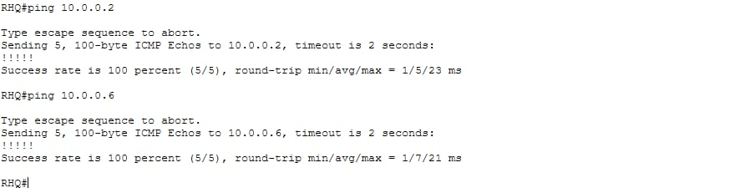
VLAN Implementation
This lab creates an isolated layer-2 infrastructure at the Corporate Headquarters using a Cisco Catalyst 2960 switch linked to a Cisco 2911 router. The single broadcast domain is broken into five distinct departmental subnets using VLSM.
VLANs were configured on all switches to logically separate departments into independent broadcast domains. The network is organized using a VLAN structure that separates departments into different logical networks to improve security, performance, and management. VLAN 10 is assigned to the Administration department, VLAN 20 to the Information Technology (IT) department, VLAN 30 to Human Resources (HR), VLAN 40 to the Finance department, and VLAN 50 to network printers. To ensure consistency, simplify troubleshooting, and streamline network administration, the same VLAN IDs are maintained across the Headquarters and both branch offices. This standardized VLAN design allows devices in the same department at different locations to follow a uniform addressing and management scheme while remaining logically separated from other departments.
CLI Command Script Execution
Switch>enable
Switch#configure terminal
Switch(config)#hostname SWHQ
SWHQ(config)# vlan 10
SWHQ(config-vlan)# name ADMIN
SWHQ(config-vlan)# vlan 20
SWHQ(config-vlan)# name IT
SWHQ(config-vlan)# vlan 30
SWHQ(config-vlan)# name HR
SWHQ(config-vlan)# vlan 40
SWHQ(config-vlan)# name FINANCE
SWHQ(config-vlan)# vlan 50
SWHQ(config-vlan)# name Printer
SWHQ(config-vlan)# exit

VLAN Port assignment
SWHQ (config)#interface range FastEthernet 0/2 - 3
SWHQ (config-if)# switchport access vlan 10
SWHQ(config-if)#switchport mode access

SWHQ (config-if)#interface range FastEthernet 0/4 - 5
SWHQ (config-if)# switchport access vlan 20
SWHQ (config-if)#switchport mode access

SWHQ (config-if)#interface range FastEthernet 0/23 - 24
SWHQ (config-if)# switchport access vlan 20
SWHQ (config-if)#switchport mode access

SWHQ (config-if)#interface range FastEthernet0/6 - 7
SWHQ(config-if)# switchport access vlan 30
SWHQ (config-if)#switchport mode access

SWHQ(config-if)#interface range FastEthernet 0/8 - 9
SWHQ(config-if)# switchport access vlan 40
SWHQ(config-if)#switchport mode access

SWHQ (config-if)#interface FastEthernet 0/20
SWHQ (config-if)# switchport access vlan 50
SWHQ(config-if)#switchport mode access
SWHQ(config-if)#exit
Verifying vlan creation and port assignment using show vlan brief
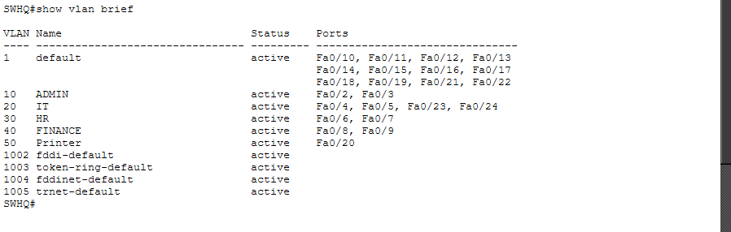
Inter-VLAN Routing
Router-on-a-Stick architecture was implemented using FastEthernet subinterfaces.
RHQ>en
RHQ#configure terminal
RHQ(config)#interface FastEthernet 0/1
RHQ(config_if)#switchport mode trunk
RHQ(config-if)# switchport trunk allowed vlan all

Sub-interface creation on HQ Router:
RHQ>en
RHQr#configure terminal
RHQ(config)#interface FastEthernet 0/0
RHQ(config-if)#no ip address
RHQ(config-if)#no shutdown

Configure VLAN 10 Subinterface
RHQ(config-if)#interface FastEthernet 0/0.10
RHQ(config-subif)#encapsulation dot1Q 10
RHQ(config-subif)#ip address 192.168.10.1 255.255.255.192
RHQ(config-subif)#exit

Configure VLAN 20 Subinterface
RHQ(config)#interface FastEthernet 0/0.20
RHQ(config-subif)#encapsulation dot1Q 20
RHQ(config-subif)#ip address 192.168.10.65 255.255.255.224
RHQ(config-subif)#exit

Configure VLAN 30 Subinterface
RHQ(config)#interface FastEthernet 0/0.30
RHQ(config-subif)#encapsulation dot1Q 30
RHQ(config-subif)#ip address 192.168.10.97 255.255.255.224
RHQ(config-subif)#exit

Configure VLAN 40 Subinterface
RHQ(config)#interface FastEthernet 0/0.40
RHQ(config-subif)#encapsulation dot1Q 40
RHQ(config-subif)#ip address 192.168.10.129 255.255.255.240
RHQ(config-subif)#exit

Configure VLAN 50 Subinterface
RHQ(config)#interface FastEthernet 0/0.50
RHQ(config-subif)#encapsulation dot1Q 50
RHQ(config-subif)#ip address 192.168.10.145 255.255.255.240
RHQ(config-subif)#exit
Verifying configuration:
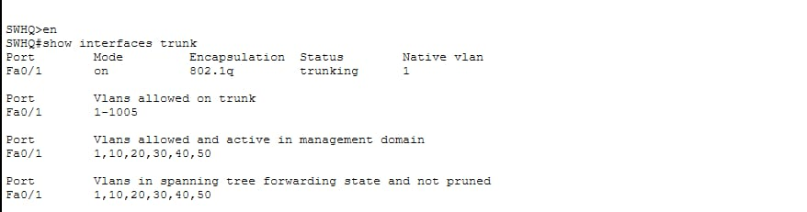

OSPF Dynamic Routing
The enterprise network uses Multi-Area OSPF (Open Shortest Path First) as its dynamic routing protocol to facilitate efficient communication between the headquarters and branch offices. The Headquarters router (R1) is configured as the backbone router in Area 0, while Branch Office 1 router (R2) operates in Area 1 and Branch Office 2 router (R3) operates in Area 2. This multi-area design improves network organization and performance by dividing the routing domain into manageable sections while maintaining connectivity through the backbone area. OSPF enables automatic route discovery and exchange, allowing routers to dynamically learn network paths without requiring manual route configuration. The implementation provides several benefits, including enhanced scalability for future network expansion, faster convergence in the event of network changes or failures, and reduced administrative overhead through automated routing updates. As the backbone router, R1 interconnects all OSPF areas, ensuring seamless communication and efficient routing between the headquarters and both branch offices.

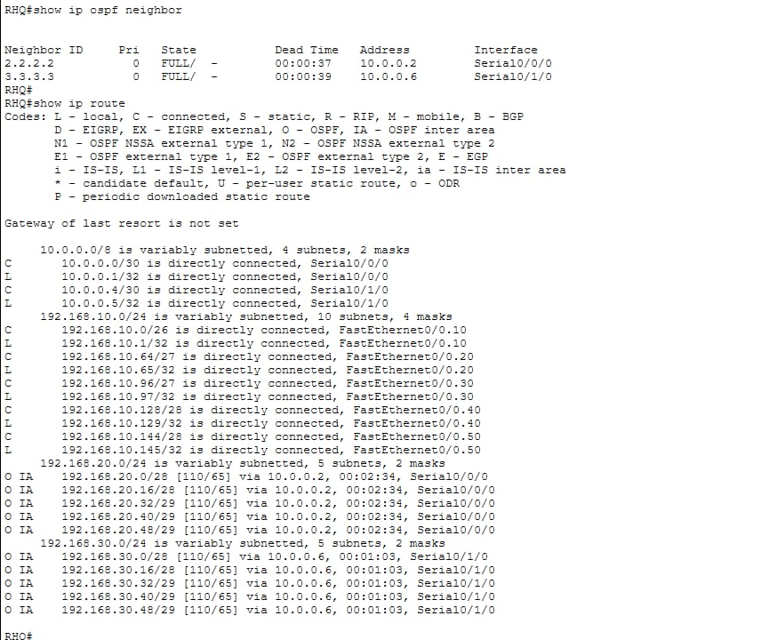

Server deployment
A centralized enterprise server was deployed at the Headquarters to provide essential network services for all locations within the organization. The server is located in VLAN 20 (Information Technology) and is configured with the IP address 192.168.10.66, subnet mask 255.255.255.224, and default gateway 192.168.10.65. By placing the server within the IT VLAN, network administrators can efficiently manage and secure critical services. The server hosts both HTTP and DNS services, enabling users across the enterprise to access web-based resources and perform domain name resolution. This centralized deployment simplifies administration, reduces infrastructure costs, and ensures that all branch offices can reliably access shared network services through the WAN and OSPF-routed network.
Verifying configuration by pinging:
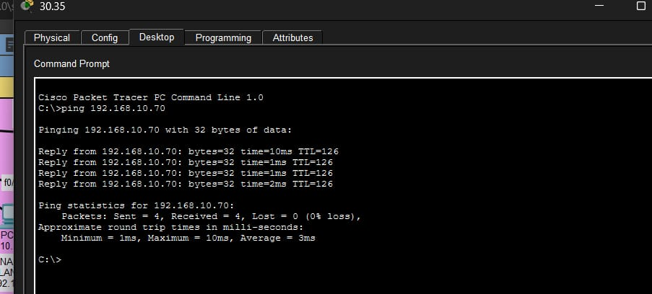
Printers and Wireless network implementation
A dedicated Printer VLAN (VLAN 50) was implemented across the enterprise network to provide a secure and organized printing environment. Printers at each site were assigned static IP addresses to ensure consistent accessibility and simplified administration. The printer at Headquarters was configured with the IP address 192.168.10.146, while the printers at Branch Office 1 and Branch Office 2 were assigned 192.168.20.50 and 192.168.30.50, respectively. Separating printers into their own VLAN enhances network security by limiting direct access from other departments, simplifies centralized printer management, and enables easier implementation of printing policies and access controls across the organization.
To support wireless connectivity, wireless access points were deployed at the Headquarters and both branch offices. All access points were configured with the common SSID "Company_WiFi", providing users with a consistent wireless experience regardless of location. A dedicated Wireless VLAN (VLAN 60) was established at each site to segregate wireless traffic from wired departmental networks. The wireless network at Headquarters uses the 192.168.10.160/28 subnet, while Branch Office 1 and Branch Office 2 use the 192.168.20.56/29 and 192.168.30.56/29 subnets, respectively. This design improves network organization, enhances security through traffic separation, and allows wireless users to securely access enterprise resources across the WAN-connected network.
Network Testing and verification
Network verification and testing were conducted to ensure that all components of the enterprise network were functioning correctly and meeting the design requirements. Several diagnostic and monitoring commands were used during the validation process, including show vlan brief to verify VLAN assignments, show interfaces trunk to confirm trunk link configurations, show ip interface brief to check interface status and IP addressing, show ip route to examine routing table entries, show ip ospf neighbor to verify OSPF neighbor relationships, and show access-lists to validate Access Control List (ACL) configurations. Connectivity testing was also performed using ping and tracert commands to verify end-to-end communication across the network. The testing results confirmed successful inter-VLAN communication between authorized departments, proper OSPF route propagation across all sites, reliable access to the centralized server by IT users, printer accessibility from authorized networks, correct enforcement of security policies through ACLs, and stable wireless connectivity at the Headquarters and both branch offices. These successful tests demonstrated that the network was operating efficiently, securely, and according to the intended design specifications.
Verifying configurations:
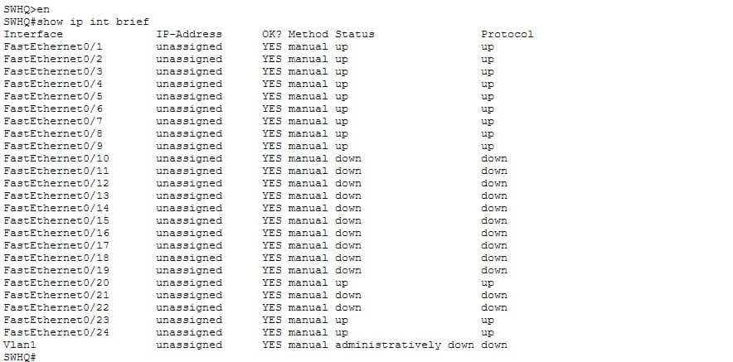

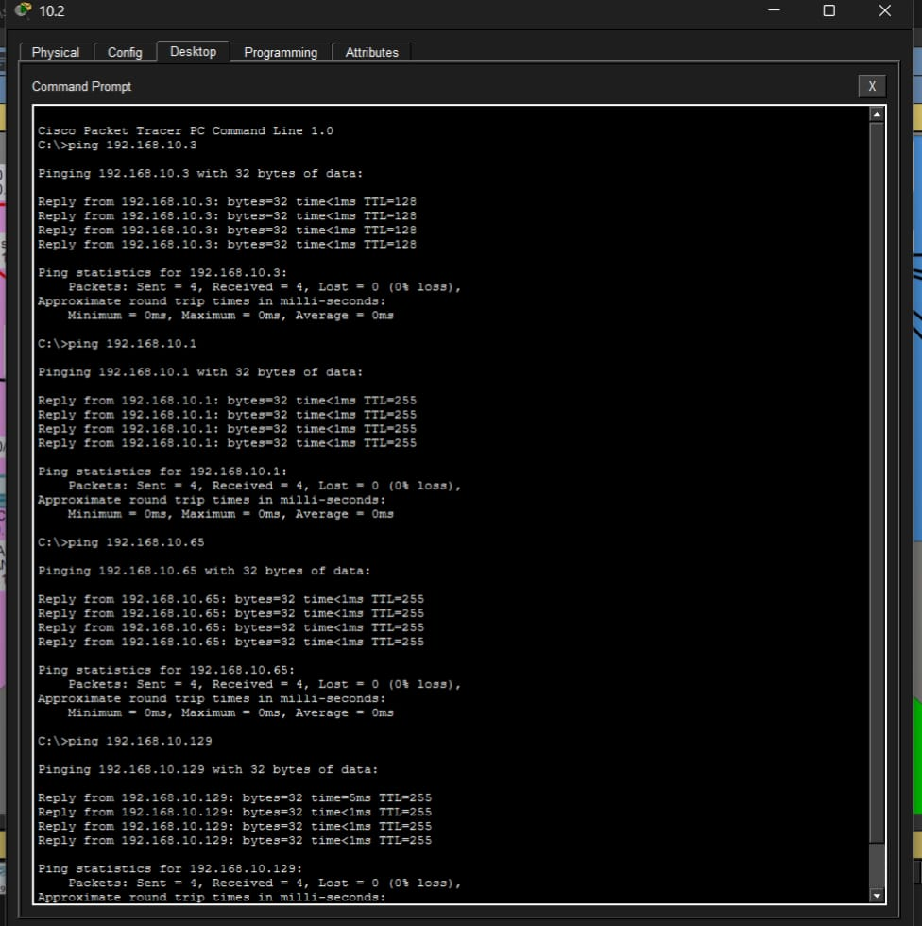

Challenges Encountered
During the implementation of the enterprise network, several challenges were encountered and successfully resolved. One of the primary issues involved an OSPF area mismatch, which prevented routers from establishing OSPF adjacencies and exchanging routing information. This problem was resolved by ensuring that the WAN links were configured within Area 0 and by verifying OSPF neighbor relationships using appropriate diagnostic commands. Another challenge involved VLAN misconfiguration, where end devices were unable to communicate across VLANs. Troubleshooting revealed inconsistencies in VLAN assignments and trunk configurations. The issue was addressed by verifying VLAN memberships, confirming trunk link operation, and validating the Router-on-a-Stick configuration used for inter-VLAN routing. Additionally, difficulties were experienced with Access Control List (ACL) implementation, as incorrect ACL placement and direction resulted in unintended traffic blocking. This was resolved by applying ACLs as close as possible to the traffic source and thoroughly testing network traffic to ensure that only the intended restrictions were enforced.

Results Achieved
The completed enterprise network successfully met all design objectives and functional requirements. Departmental traffic was effectively segmented using VLANs, improving both network organization and security. Variable Length Subnet Masking (VLSM) enabled efficient utilization of IP address space across the headquarters and branch offices. Dynamic routing was successfully implemented using Multi-Area OSPF, allowing automatic route discovery and efficient communication between all locations. Centralized services, including HTTP and DNS, were deployed on a dedicated server at the headquarters, providing reliable access to enterprise resources. Wireless connectivity was integrated through dedicated wireless VLANs and access points at each site, ensuring seamless user access across the organization. Security was enhanced through the implementation of ACLs, which controlled access to critical resources and enforced organizational policies. Overall, the network achieved secure and reliable end-to-end communication between the headquarters and branch offices while providing a scalable and manageable infrastructure for future growth.
Industrial Application and Business Case
In a production enterprise environment, separate departments (such as Administration, Finance, and IT Management) must be isolated at the data link layer to secure confidential records and control broadcast traffic. This layout isolates departmental traffic using VLANs, while allowing necessary cross-departmental communication through controlled inter-VLAN routing.
3.2.3 Security and Access Control Implementation
The perimeter router uses Extended Access Control Lists (ACLs) to protect internal core devices from external network tracking. The security policies are written to block unauthorized management connections (like Telnet and SSH) originating from the remote branch network into the HQ core switches, while permitting standard internet traffic (HTTP, HTTPS, and ICMP diagnostic pings) to pass unfiltered.

